Blog 4

When I am doing the homepage, I would like to add some images next to the text. I add the <img> code in the HTML, the image appears on its default left side.

This is how I want to do:

In an area, there are a few paragraphs on the left and the image on the middle-right.

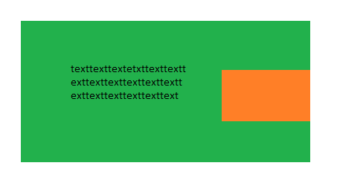

I kept trying different codes between the container, the text and the image, but none of them did what I want.

I used to set the width of the container for 100%, then the width of text for 70% and the width of the image for 30%. It changes the width of them but they stack on top each other but not line-up next to each other.

I change the CSS of the image to float: right, it appeared on the right side but is sitting in the bottom-right corner and I want it to be on middle-right side. Based on this code, I add top: 30% trying to bring the image up to the middle, but it still didn’t place in where I want it to be.

I tried adding position: relative in the container, adding position: absolute in the image. The image was located in the position I want it to be, but it overlapped with the text and part of the text is being covered.

I talked to Phill about it, he suggests using display: flex, align-item: center, and justify-content: space around within a container, then use flex: 1 for the text and the image. I add class=”container” into a section that contains some other thing, the same code did not work, but then he told me the display: flex property only can use within a container with only two things, so I made a container to wrap up the text and the image. It appeared in the live server that the text and the image line-up together, but I want to set the width the them so the text contains 70% in the container and the image contains 30%. I can change the height of the image but I cannot change the width, the text and image are half and half in the browser. I looked at my code and eventually I figured out to change the flex of the text and the image, the larger number of flex means wider in the container, the smaller number of flex mean shorter in the container, I had spent 5 or 6 hours on fixing this image between the text and finally managed to figure out how to change it.